DevOps Fundamentals – Trainer Notes by Mohamed Shibli Alfathih

1. What Is DevOps?
DevOps = Development + Operations
DevOps is a culture and set of practices that unite software development and IT operations.
Its goal is to build, test, and release software faster, more reliably, and with fewer errors.
📘 Example:
Earlier, developers-built code and handed it off to operations. Now, both work together using automation and monitoring tools.
Main Benefits:
- Faster deployments
- Better teamwork between Dev & Ops
- Improved reliability and feedback
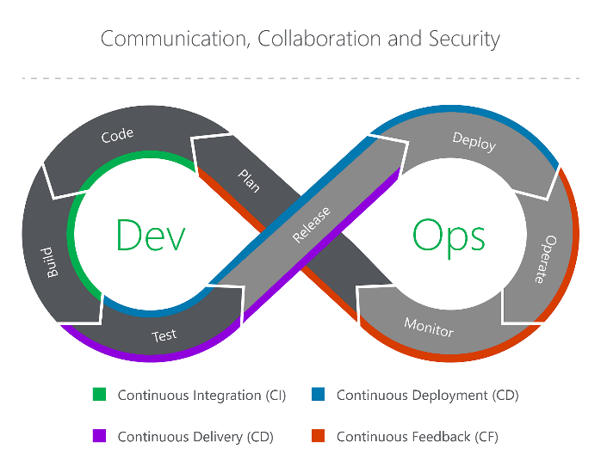
2. How DevOps Evolved
Feature | Waterfall | Agile | Scrum | DevOps
Methodology | Traditional, linear, and sequential. Each phase must be completed before the next begins. | An iterative, incremental approach. Projects are broken into short cycles called sprints. | An agile framework that follows specific roles, events, and artifacts to complete work in short sprints. | A cultural and practice-based approach that integrates Development (Dev) and Operations (Ops) teams.
Flexibility | Rigid and inflexible. Changes are expensive and difficult to implement once a phase is complete. | Highly flexible and responsive to change. New requirements are welcomed, even late in the process. | Flexible within each sprint. The scope can be adjusted between sprints based on feedback. | Highly adaptive. Continuous feedback loops allow for constant adjustments throughout the entire lifecycle.
Customer Involvement | Low. The customer is typically involved only at the beginning (requirements gathering) and end (final delivery). | High. Customers collaborate throughout the development process, providing feedback after each iteration. | High. The product owner represents the customer and stakeholders, and stakeholders review the working product at the end of each sprint. | Continuous. Feedback is a fundamental part of the process, with monitoring and user feedback informing constant improvements.
Delivery | A single, final delivery at the end of the project. | Incremental delivery of a working product at the end of each short iteration. | Frequent deliveries of "potentially shippable increments" at the end of every sprint. | Continuous delivery and deployment. Automated pipelines release new code frequently and reliably.
Risk | High. Issues may not be found until the final testing phase, making them costly to fix. | Lower risk due to continuous testing and frequent feedback, which catches issues earlier. | Lower risk. Sprints are short, so if a direction is wrong, the course can be corrected quickly with minimal impact. | Low. Automation, continuous testing, and monitoring help catch issues immediately and minimize failures.
Best For | Projects with well-defined, stable requirements (e.g., construction or large, regulated government projects). | Projects with evolving requirements and a need for adaptability, especially in software development. | Complex product development where requirements are dynamic and collaboration is key. | Organizations needing to deliver high-quality software at high velocity, bridging the gap between developers and operations.

3. Key Roles and Responsibilities
Role | Description
DevOps Engineer | Automates CI/CD pipelines, integrates tools, manages infra.
System Administrator | Manages OS, networking, and server availability.
Cloud Engineer | Works on AWS, Azure, or GCP for deployments.
Security Engineer (SecOps) | Secures pipelines and manages access.
Infrastructure Engineer | Designs physical and virtual infrastructure.
QA Engineer | Automates and validates testing.

4. DevOps in SDLC (Software Development Lifecycle)
Phase | DevOps Involvement
Plan | Jira, Confluence for planning
Build | Git, Jenkins for builds
Test | Selenium, JMeter, etc.
Deploy | Terraform, Ansible
Monitor | Prometheus, Grafana, New Relic
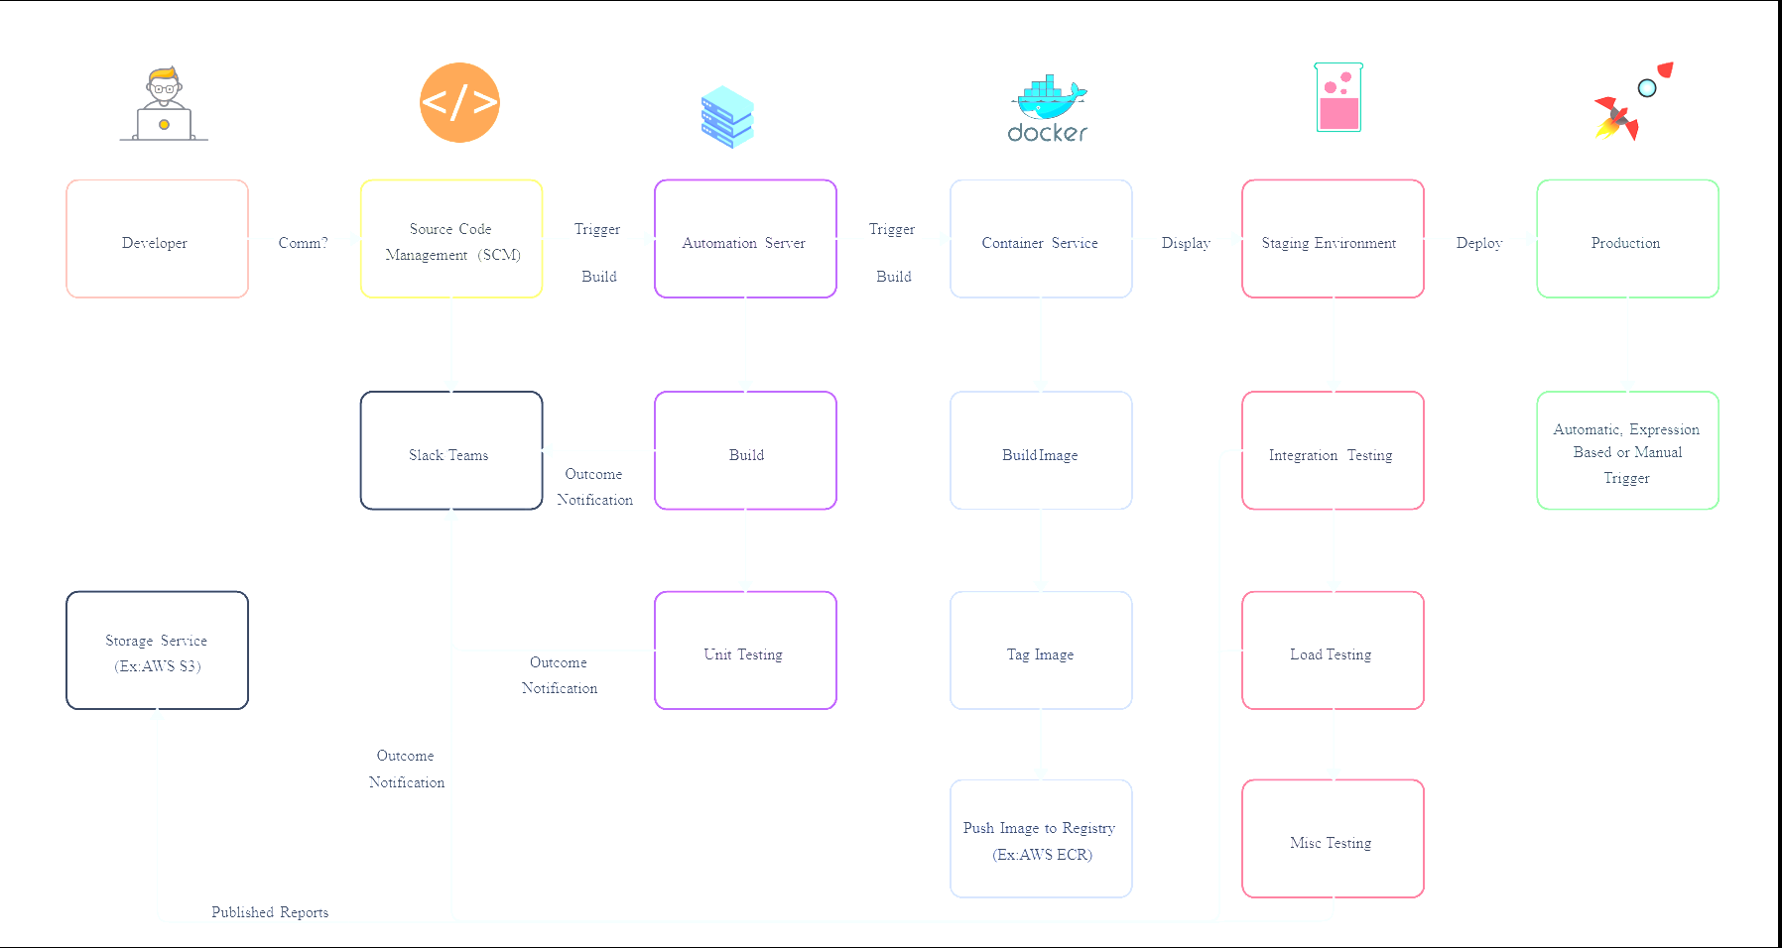
5. Dev, QA, and Production Environments
Environment | Purpose
Dev | Developers test new features locally.
QA/Staging | Quality assurance and pre-production validation.
Prod | Live environment where users access services.
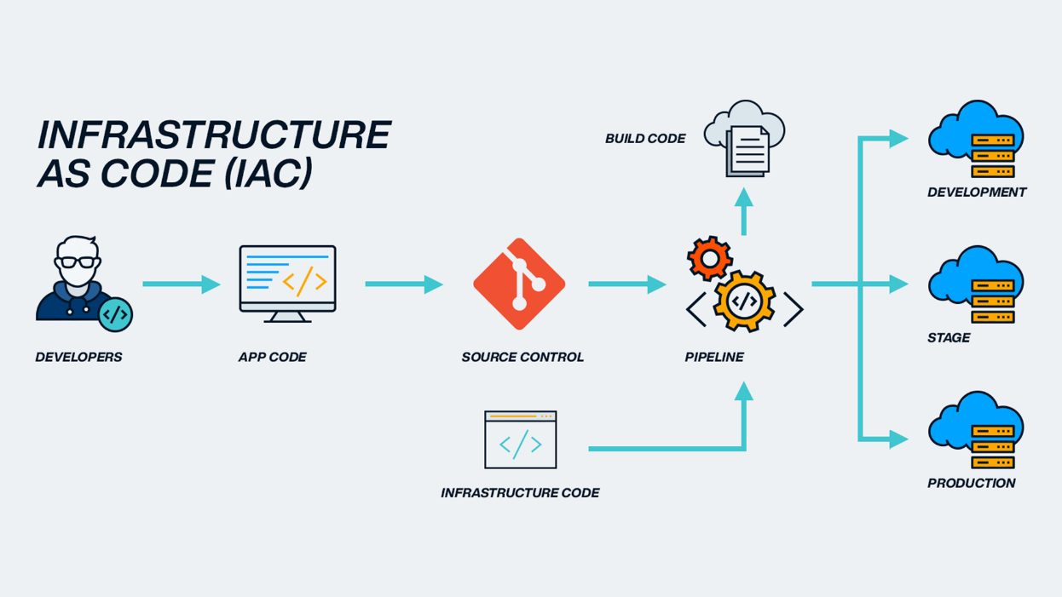
6. Core DevOps Tools
Category | Examples
Version Control | Git, GitHub, GitLab
CI/CD | Jenkins, ArgoCD, Azure DevOps
IaC (Infrastructure as Code) | Terraform, CloudFormation
CM (Configuration Mgmt) | Ansible, Puppet
Containers | Docker, Kubernetes
Monitoring | Prometheus, Grafana
Observability | New Relic, ELK Stack

7. Infrastructure Concepts
🏢 On-Premises
- Hardware owned and managed by your company.
- More control, but higher cost.
☁️ Cloud
- Infrastructure managed by providers like AWS, Azure, GCP.
- Scalable and pay-as-you-go.
🔄 Hybrid
- Combines on-prem and cloud.

8. Cloud Service Models
Model | What You Manage | Example
IaaS | OS + Applications | AWS EC2, Azure VM
PaaS | Code only | Heroku, Elastic Beanstalk
SaaS | Nothing – everything managed | Gmail, Salesforce

9. Security Basics in DevOps
- Secure secrets and credentials (use Vaults).
- Scan images for vulnerabilities.
- Apply role-based access (IAM).
- Monitor and audit continuously.

10. Virtualization & Cloud Foundations
10.1 What Is Virtualization?
Virtualization allows one physical computer to run multiple virtual machines (VMs).
Each VM acts like a separate computer with its own OS and storage.
Advantages:
- Efficient use of hardware
- Isolation between environments
- Easier backup and cloning
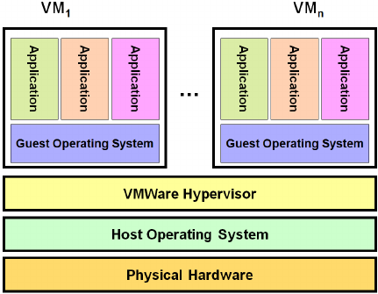
10.2 Virtual Machines (VMs)
A VM is a software-based computer running on a host machine.
Each VM can have its own:
- CPU (virtual)
- RAM
- Storage
- OS
Examples:
- Ubuntu VM running on Windows (VirtualBox)
- Test servers on VMware ESXi

10.3 What Are Hypervisors?
A Hypervisor is software that creates and manages virtual machines.
It sits between the hardware and the VMs.
Types of Hypervisors:
Type | Description | Examples
Type 1 (Bare Metal) | Runs directly on physical hardware. | VMware ESXi, Microsoft Hyper-V Server
Type 2 (Hosted) | Runs on top of an existing OS. | Oracle VirtualBox, VMware Workstation
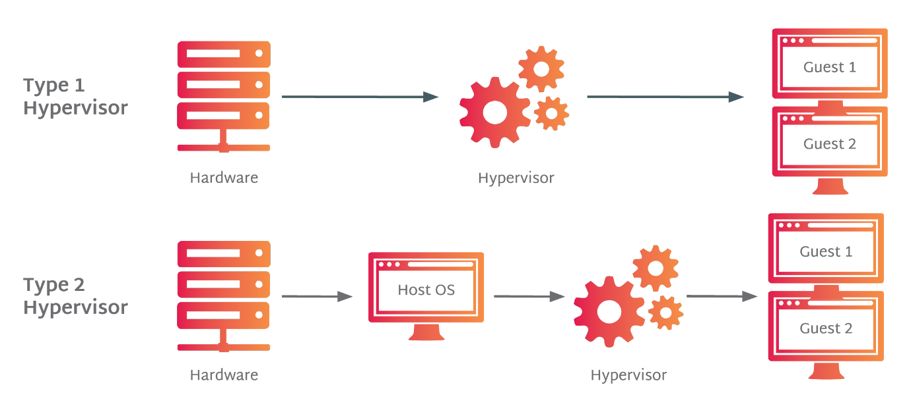
10.4 Operating Systems (OS)
Definition:
An OS manages hardware and software resources and provides a user interface.
Types:
- Windows → GUI-based, user-friendly
- Linux → CLI-based, open source, secure
- macOS → Apple’s Unix-based OS

10.5 Why Linux for DevOps?
- Open-source and free
- Lightweight and stable
- Better control via command line
- Most DevOps tools (Docker, Jenkins, Ansible) run natively on Linux

10.6 Oracle VirtualBox Overview
- Free, open-source Type-2 hypervisor from Oracle
- Runs multiple OSs simultaneously
- Allows snapshots, shared folders, and networking

10.7 Cloud Tech Stacks
Cloud Provider | Common Services
AWS | EC2 (compute), S3 (storage), Lambda (serverless), RDS (DB)
Azure | Virtual Machines, Blob Storage, Functions
GCP | Compute Engine, Cloud Storage, BigQuery
Others | DigitalOcean, Linode, Oracle Cloud

⚙️ 10.8 Installing Oracle VirtualBox on Windows
Prerequisites:
- Windows 10/11 (64-bit)
- 8 GB RAM, 50 GB storage
- Enable virtualization (VT-x/AMD-V) in BIOS
Steps:
- Download from virtualbox.org.
- Run setup → follow wizard → allow network adapter installation.
- Launch VirtualBox after installation.

10.9 Creating an Ubuntu CLI Server VM
- Open VirtualBox → Click New
- Name: Ubuntu-CLI-Server
- Type: Linux, Version: Ubuntu (64-bit)
- Allocate 2 GB RAM, 1 CPU core
- Create 40 GB VDI disk
- Attach Ubuntu Server ISO
- Start VM → Install Ubuntu Server
- Update system:
- sudo apt update && sudo apt upgrade -y

